**Experiment1: Operating images using Python**

**Class __________ Name _____________ Student No. __________________**

**Task1: Image and Multi-dimensional array**

**1. Use PIL and numpy to access image data**

The file “testimage.bmp” is a three-channel color image, via image browsing software, you may know it is a pure red image. Using example script below, you will use **PIL.Image** lib to open the image, and further transfer it to numpy array. Afterwards, you can access the data in the numpy array.

image_PIL = Image.open("testimage.bmp")  
image_PIL_np = np.array(image_PIL)  
print('shape of the image is {}'.format(image_PIL_np.shape))

Please answer following questions by print function or watch variables in debug mode:

1) The width, height, channel number of the image are ____640____, ____427____,____3____, respectively, corresponding to the __2nd______, ___1st_____,__3rd______ dimension of the numpy array.

2) Started from the 0 channel, the pixel intensity values in each channel are ___255_____, ____0____,____0____, respectively. Considering the image you saw, the sequence of channels is __RGB____ (RGB/BRG).

3) By inspecting the ‘dtype’ property of the numpy array, the data type of the array is ____unit8___(int32, float, double, uint8, bool).

**2. Showing image with matplotlib and OpenCV**

Given the numpy array obtained below, please try these two methods to show the corresponding image:

*from* matplotlib *import* pyplot *as* plt  
plt.imshow(image_PIL_np)  
plt.show()

*import* cv2  
cv2.imshow('winname', image_PIL_np)  
cv2.waitKey()

According to the results you obtained, you can infer that the imshow method in matplotlib, assumes images are stored in ______RGB___ (RGB/BGR) format. The imshow method in cv2, assumes images are stored in ___BGR______ (RGB/BGR) format

**3. Other libraries for image**

Please try out different libraries, and answer following questions:

1) Using **imread** method in **imageio** to open image, the channel sequence of array is ___427___, _640_ , _3_;

2) Using **imread** method in **skimage.io** to open image, the channel sequence of array is ___427___, _640_ , _3_;

3) Using **imread** method in **skimage.io** to open image (and further transfer to numpy array), the channel sequence of array is ___427___, _640_ , _3_;

**4. Creating an image using numpy**

Please try to create and save an image (you can do this via imwrite method in **imageio**) shown as following. To realize this, you may need to initialize a numpy array, and fill in appropriate values in specific locations or channels. Please finish this task and provide implemented scripts.



**Your scripts:**

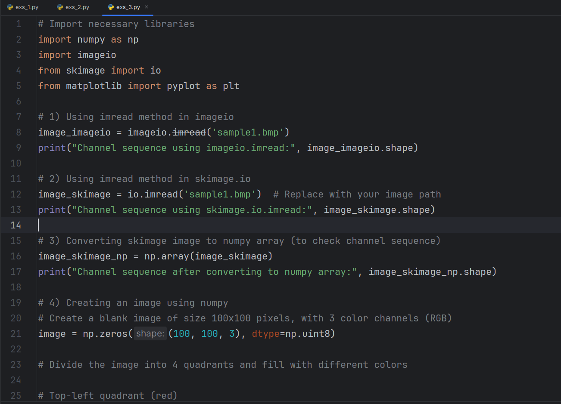

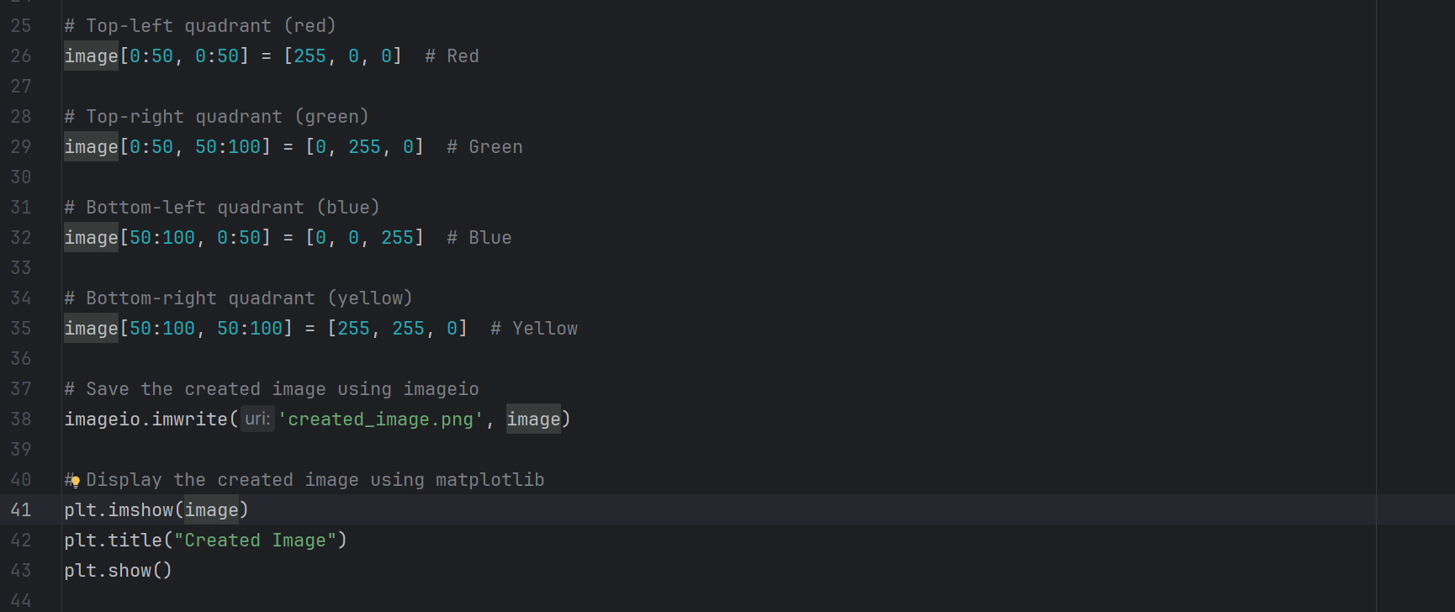

Results:

